**LOBBYING**

(4 min read)

In this article, we aim to clear the misconceptions about lobbying and identify the influence of the lobbyists in the USA. We do this by using effective visualizations which represent each of the problems.

At its basic level, lobbying is something that ordinary people do all the time.  It is part of human nature to explain or advocate for a certain need or purpose.  For example, children lobby their parents for a toy they want, or raise in their allowance. In politics, lobbying, persuasion, or interest representation is the act of lawfully attempting to influence the actions, policies, or decisions of government officials, most often legislators or members of regulatory agencies. Lobbying, which usually involves direct, face-to-face contact, is done by many types of people, associations, and organized groups, including individuals in the private sector, corporations, fellow legislators or government officials, or advocacy groups (interest groups).

Bribery and lobbying are often conjoined in the public mind: Critics of lobbying suggest that it is bribery in a suit. While both seek a favorable outcome, the two remain distinct practices. Bribery is considered an effort to buy power—paying to guarantee a certain result; lobbying is considered an effort to influence power, often by offering contributions. The main difference: Bribery is considered illegal, while lobbying is not Lobbying is the organizing of a group of like-minded people, industries, or entities to influence an authoritative body or law-making individual, often through financial contributions.

**Figure 1**

*Median lobbyist revenue*

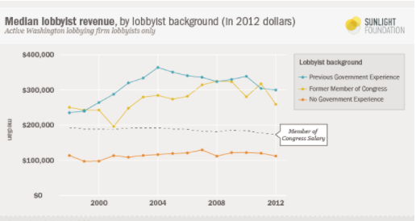

Note. [1]

In this visualisation, you can see a comparison between the median revenue of a lobbyist in USA and the average salary of a Congressperson. The different lines represent the following:

* The blue line represents lobbyists with previous government experience.
* The yellow line represents lobbyists who were former members of Congress.
* The orange line represents lobbyists with no prior government experience.
* All these lines are compared to the black dotted line which represents the average salary of a Congressperson.

So, we can now deduce that the median salary of a lobbyist who either have previous government experience or were former members of congress is way higher than the lobbyist with no government experience as well as the average salary of a member of congress.

The reason for this bridge in incomes of lobbyists having prior government experience and lobbyists with no such experience is the **“revolving door concept”.**

This concept explains that previous members of congress and government employees move to the industry of lobbying and our paid heavily for the network and connections they developed during their tenure.

**Figure 2**

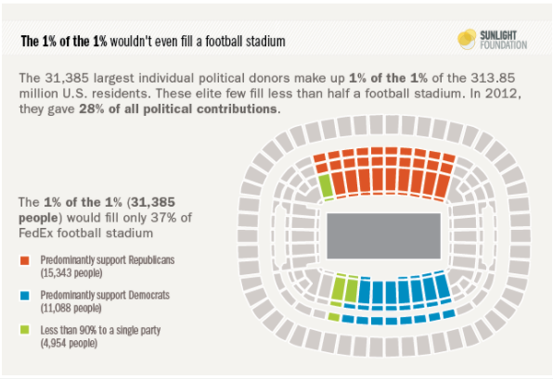

Note. [2]

One might wonder if this is really a visualization. In fact, it surely is. This is a stadium where only half of the stands are coloured (or basically filled) which implies that the number of people indulged in lobbying activities are so less that they will not even fill half an average football stadium. In numeric terms, it is only about 30,000 people which is just 1% of the 1% of the total US Population.

They influence all the major decisions of the government and are hence termed as, *“Elite of the Elites”*.

The different colours show what parties these donors support.

* + The ones in red predominantly support the Republicans.
  + The blue ones support the democrats
  + The ones in green are loyal towards one single party.

**Figure 3**

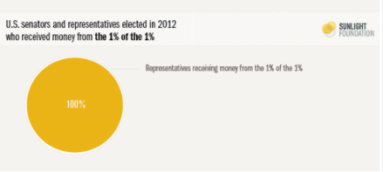

Note. [3]

Coming to the pie chart, it depicts that in 2012, a 100%, that is all the elected officials and congressmen accepted funding from these lobbyists for their campaigns or other purposes.

**Figure 4**

*Recent presidential administrations rank in their links to lobbyists*

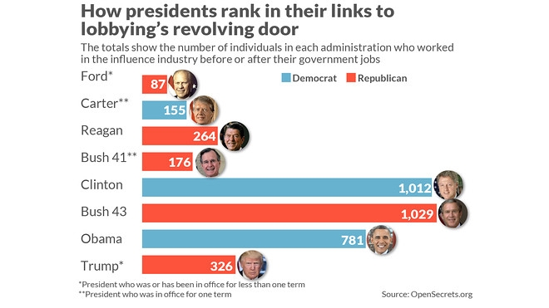

Note. [4]

This visualisation shows data regarding the number of lobbying activities which took place under the tenure of different presidents. As you can see each president in US has been indulged in lobbying activities.

The number written on the bars shows the total number of individuals involved in lobbying activities under their respective tenures. The presidents with the red coloured bars are the Republicans while the ones with blue coloured bars are Democrats.

The number of asterisk (*) sign indicates the tenure of the respective Presidents:

* + Single asterisk (*) - tenure lasted for less than one term
  + Double asterisk (**) – tenure lasted for exactly one term
  + No asterisk – tenure lasted for more than one term.

The purpose of lobbying is to influence government policy and its implementation and to help set the political agenda. In conclusion lobbying can be good and bad for the American people and the world. It all depends on the interest group that is putting the most bugs in the ears of Congress members and what the lobbyists are being told to say. Lobbying makes the public’s voices heard which is good but who decided if the public knows exactly what is good for the public.

TEAM 2

1. (Furnas, 2014). K Street pays top dollar for revolving door talent. <https://sunlightfoundation.com/2014/01/21/revolving-door-lobbyists-government-experience/>
2. (Cesal, 2014). Data visualization for the Sunlight Foundation. <https://www.amycesal.com/dataviz>
3. (Cesal, Amy Cesal, 2014). Data visualization for the Sunlight Foundation. <https://www.amycesal.com/dataviz>
4. (Reklaitis, 2019). How the Trump presidency ranks against prior administrations in links to lobbyists — in one chart. <https://www.marketwatch.com/story/how-the-trump-presidency-ranks-against-prior-administrations-in-links-to-lobbyists-in-one-chart-2019-01-18>